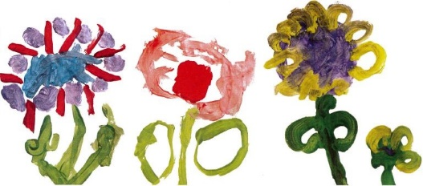
Together we play, talk, listen and learn

Edith Kerrison School Improvement Priorities
The Quality of Education

We intend children to have access to a broad and balanced curriculum that equips them with what they need for the future. We will implement this through reviewing our core provision, delivering a programme of professional development to enhance our staff expertise and sharing good practice with other settings.

Behaviour and attitudes

We intend children to have high levels of well-being and positive attitudes to learning. We will implement this by providing clear policies, procedures and guidance and identifying concerns and targeting support.

Personal Development

We intend to further improve our provision for the personal development of all children building confidence and resilience. We will implement this by improving our garden and developing core outdoor experiences, nurturing children’s self- confidence and self- awareness and work with primary schools to ensure children are equipped for their reception class.

Leadership and management

We intend leaders to focus their attention on the education provided by the school to lead to better outcomes for children. We will implement this by ensuring all leaders are supported and challenged in their leadership and plans to improve outcomes for children, measuring and evaluating the impact of changes across the school.

