Edith Kerrison Early Years Pupil Premium: Impact on Children’s learning 2018/2019
School context
Total number of pupils eligible for pupil premium funding | Number of eligible boys | Number of eligible girls | Number of eligible children with SEND | Number of looked after children (LAC) | Number of children identified as vulnerable | Number of parents who completed PICL
16 | 4 | 12 | 3 | 1 | 4 | 10 (63%)

What will the money be spent on? | To fund an EYP (1 day) to work with identified children’s parents to develop their knowledge and understanding of how they can be involved in their child’s learning through a 10week programme (PICL – Parents involved in Children’s Learning). The EYP works alongside the CC family support worker involving parents in their child’s learning to ensure engagement of all target and vulnerable parents in parent programmes/workshops that meet their family’s needs.  To fund educational visits to the theatre and the beach to enhance children’s cultural capital and further develop vocabulary.
Why have we chosen this? | We recognise parents/carers are children’s first educators. Children in the nursery spend the majority of their time with their parent/carer. It is from parents children learn most in the early years. We believe Parents who are involved in their child’s learning give their child a greater opportunity to reach their full learning and development potential. When parents and professionals work together children benefit. Research and findings from the Education Endowment fund and EPPSE project show that it is not who your parents are, or how rich they are that matters, but what they do with you. Our own school data shows children from families on a low income have starting points just below expected for their age. This is intended to be an inclusive intervention which other parents can also access to make a difference not only to children from families on a low income but also the wider community.
How much will it cost? | Income was £4,800  Annual parent conference with parents delivering £58  EYP to deliver PICL one day a week £2’594  PICL consumables £500  Christmas Theatre visit £1097  Chalkwell Beach visit £886  Potential c/fwd debit £335
How will children/ families and the setting benefit? | The home learning environment is strengthened because parents have a better understanding of their child and plan activities that they enjoy to support and extend their learning.  Children will be happier, confident and emotionally strong because parents have a better understanding of how to support their child’s well-being.  Children and parents have improved parent child interactions and relationships  Other parents can also access and thereby networks of parent friendships and parent well-being are developed across the school.  Children’s achievement is enhanced because there is collaboration between home, school and community.  All staff have access to ICT equipment to capture and share children’s learning with parents
What difference did it make? | Our EYPP achievement report is provided at the end of the document and outlines children’s starting points and the amount of progress they made and their attainment at the end of the year.
How will we build on it? | Outcomes show we have spent the money effectively this year. PICL continues to be a successful intervention that has given children who need it most as much opportunity as possible to make above expected levels of progress and to be ready for their next stage in education. Next year any extra funding will be used to part fund the DHT for one day a week to work with identified children and their parents to further develop their vocabulary and cultural capital through educational visits beyond the local community. Through a variety of approaches we aim to ensure engagement of all target and vulnerable parents in parent programmes/workshops that meet their family’s needs.

EYPP Achievement Report
Attainment

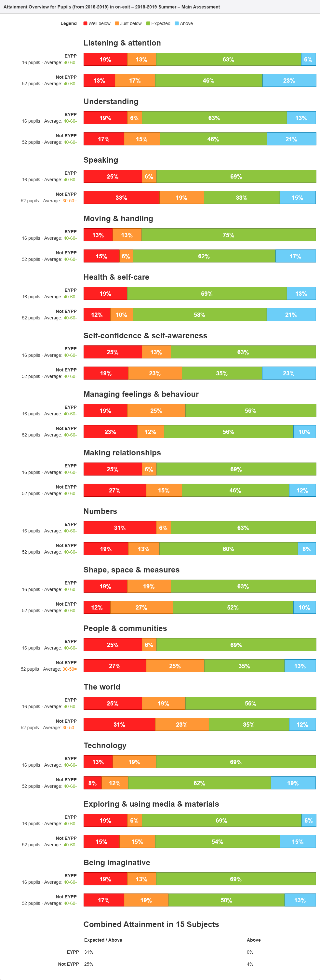

Progress
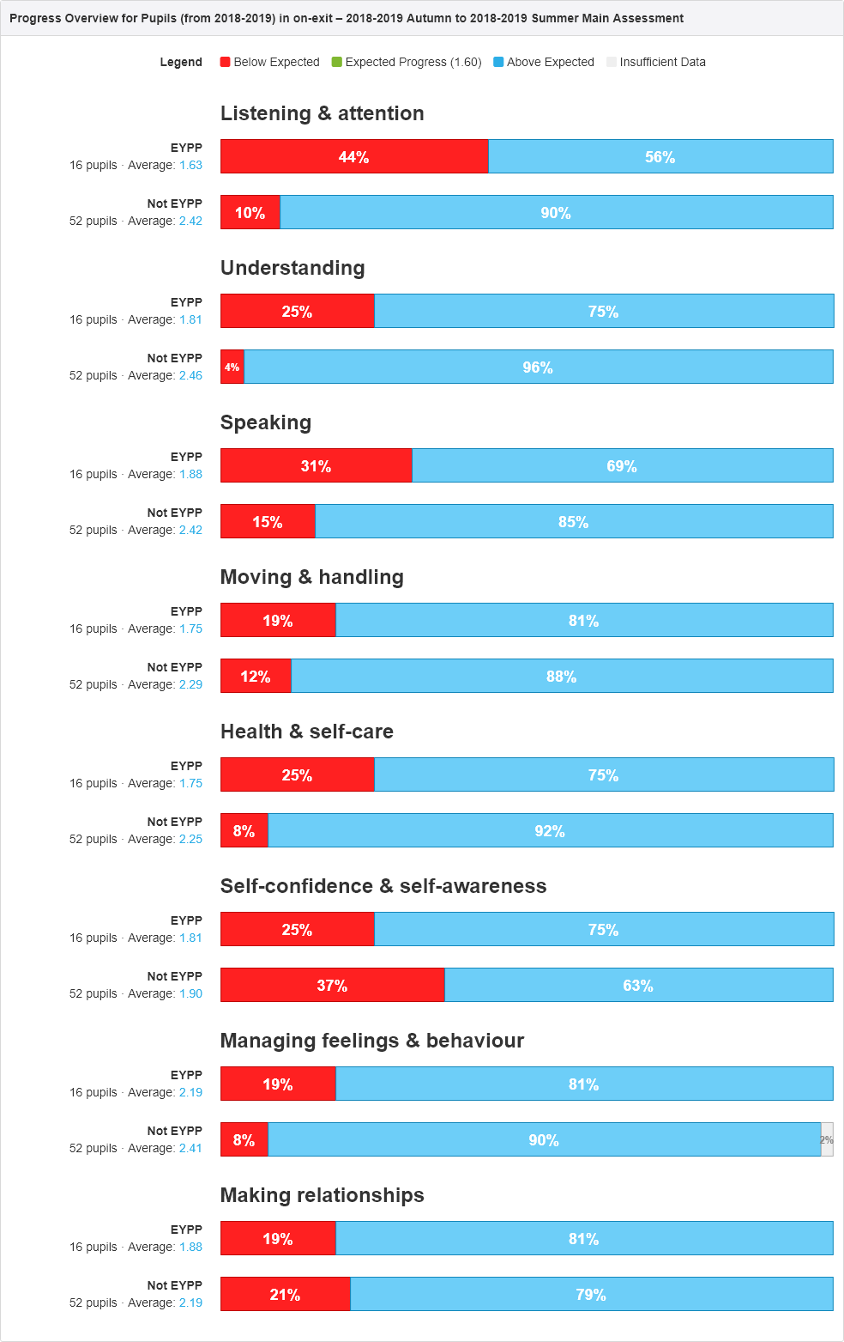
- On average children from families on a low income make above expected progress in all aspects of the prime areas of learning
- On average when children from families on low income leave the nursery they have attained at least a good level of development and learning in all aspects of the curriculum.
- 14 out of 16 parents of EYPP children’s parents attended parent workshops and 10 out of 16 committed to attending the 10 week PICL programme
- All EYPP parents have engaged in their child’s learning through attending nursery events, celebrations and educational visits as a result of school expectation, encouragement and support

