Comments and Complaints Policy

Edith Kerrison Nursery School and Children’s Centre

Together we play, talk, listen and learn

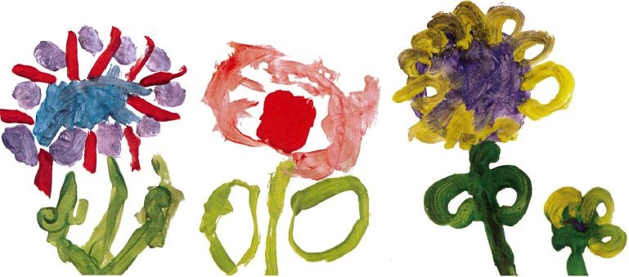

Approved by: | Governing Board | Date: July 2019
Last reviewed on: | June 2019
Next review due by: | June 2020

Rationale

To continually improve and develop our services we encourage feedback from our clients, parents, children, staff and community. There are opportunities to do this verbally through representation on school and children’s centre committees, comment boxes, pupil progress reports and daily meetings with staff. When dealing with comments and complaints we respond sincerely and with consideration to the individual experience and for the wider good.

Purpose

The purpose of this policy is to set out the procedures for gathering feedback, comments and complaints and how responses are dealt with.

Guidance on making positive comments, gathering feedback and making complaints

- Brief accessible guidance on how to provide comments and complaints is displayed on the parent noticeboard both in the school and children’s centre.

- The wording for this is attached as the comments and complaints poster and should be read in conjunction with this policy.

- The two year old room must have a complaints book clearly available.

- There is a comments box available in the nursery entrance and in the children’s centre entrance.

- Parents are required to comment on their child’s learning and teaching experience as part of the parent and child pupil progress report cycle.

- Parents walk through the nursery entrance when they bring and collect their child where there is a member of the Senior Leadership Team available to talk to about any issue and make comments.

- A place of privacy to talk through an issue is always made available.

- In the Children’s Centre there is always a member of centre staff available to take comments from clients.

- Evaluations of training sessions, parent forum consultations, session feedback led by outside agencies are routinely gathered and fed into future planning by leaders.

- Staff who wish to comment should refer to the staff grievance policy when informal comments are not dealt with to their satisfaction.

- Parents can use Parent View on the Ofsted website to record comments and complaints or contact Ofsted directly on the Ofsted helpline on 0300 123 1231.

Guidance on Responding to Comments and Complaints

- Any comments and complaints are dealt with in the first instance by the member of staff who receives it.

- A written record is saved for one year by the Head Teacher when it refers to a comment on the child’s pupil progress report around teaching and learning.

- Significant personal mementoes are stored in the Golden Book.

- All other written comments and complaints are kept until actioned and resolved in future planning.

- When a member of staff is unable to deal with a comment or complaint the matter will be referred to a more senior member of staff, until the issue has been resolved. This upward chain could include the Chair of Governors, Head Teacher and Local Authority as appropriate.

- When a comment or complaint involves the services delivered by another agency, the Senior Leadership Team will work with this service to share success, comments and complaints. When a response is required, we will work together to respond and make reasonable adjustments to services for the benefit of the wider community.

What do I do if I have a comment, complaint or concern about my childcare at the centre?
Please speak to a member of staff, if you are joyous or unhappy about anything you see or hear in the Children’s Centre or Nursery School.

- Or post a comment with or without your name in the comments box

- Or email info@edithkerrison.newham.sch.uk

If an issue remains unresolved please speak to the Head Teacher.

If you are still not happy please speak to a member of the Children’s Centre Advisory Board or the School’s Governing Body. Their photographs are displayed in the Children’s Centre and Nursery school.

If the issue remains unresolved contact the Ofsted helpline on 0300 123 1231, or email
enquires@ofsted.gov.uk

