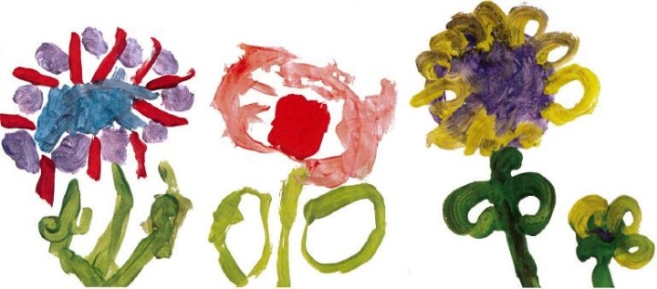
Edith kerrison Nursery School and Children’s centre
Together we play, talk, listen and learn
Charging and payments policy

Purpose of this policy
To inform prospective and current parents and service users about charges that may be made by Edith Kerrison Nursery School and Children’s Centre.
It is a statutory requirement to detail any charges that the school intends to make. Charges cannot be made for education provided during school hours but may be made for transport and other costs associated with taking children on educational visits.
For trips organised by the children’s centre a charge is made to ensure that costs are covered but these charges will not exceed the actual cost of the trip. The cost of some trips will be subsidised by Early Years Pupil Premium funding for those children entitled to it.

Nursery education places
In line with Newham’s admissions criteria, we provide 15 hours of FREE nursery education for children the term after their 3rd birthday. We also offer 15 hours of free nursery education for eligible 2 year olds. To check whether your child is eligible visit www.newham.gov.uk/twoyearoldchildcare
Nursery education is a government funded entitlement and is paid directly to the school via the local authority funding system when a child begins nursery. Please refer to our admissions policy for further details.

30 hour places for children of working parents
A small number of FREE 30 hour government funded places are available for children of working parents. The child’s day can run from 8.40 – 2.40 or 9.30 – 3.30. The full nursery day runs from 8.40-3.30 and is a 35-hour week. Parents/carers can chose to pay for the additional 5 hours at a charge of £5 per hour. Children are required to bring a healthy packed lunch. To check whether your child is eligible visit www.newham.gov.uk/30hoursfreehours

Educational visits
At least once a term we arrange trips beyond the setting that may incur transport or admission charges. The size of this voluntary contribution is calculated by dividing the cost of the trip by the number of participants. The number of participants includes the parent accompanying a child.

Library
Children are free to borrow a book from the lending library on a daily basis. If a book is lost or badly damaged at home we ask for a nominal contribution to replace it.

Snacks and drinks
Milk, water, fruit and healthy snacks are provided free on a daily basis.

Financial assistance
If any family has difficulty in meeting any requests for payment, then it may be possible, in some circumstances, for the school to wholly or partially subsidise the activity. Applications for financial help will be received sympathetically and will be regarded as confidential. The decision to offer financial support for any of the above rests with the headteacher

