Blue Team
Curriculum matters Autumn Term 2020
This term we have been settling into life at nursery. For some of us this is a return to a new class after the long break and for others it has been our transition from home to school. Those of us returning showed great resilience, settling quickly with a whole new team of adults and some changes in routine and access to areas of the nursery. With lots of adult support, most of us who entered the nursery for the first time managed to settle and are now enjoying our busy sessions. We are now making a range of friendships and learning to work together co-operatively.
We have been spending lots of time outside. The wonderful new large construction bricks have proved a great hit. We have used our imaginations to build buses, castles and rockets. Adults responded to our interest in cars and mechanics and we developed our own garage, looking online for our favourite car logos and using a mixture of building resources to build and fix our cars.
We have been fascinated by the changing season and the cheeky squirrels in our garden. We worked collaboratively together in the garden raking the leaves and weeding the flower beds. Our reward was yummy hot chocolate cooked on the bonfire.
We continued our interest in autumn inside using the autumn leaves to create a range of art work. We explored a range of different techniques to create our art work. We rolled, crushed and printed with leaves. We used pastels and sprinkled powder paint. We even used technology by using the laminator to preserve our leaves.
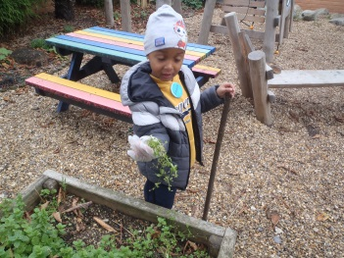
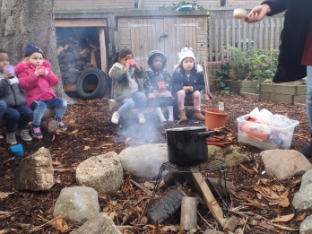
We are an imaginative bunch who engage well in small world and role play. We are beginning to use our role play voices to create roles. We used our knowledge of our favourite fairy tales of The Three Little Pigs and The Three Billy Goats Gruff to retell stories using bricks.
